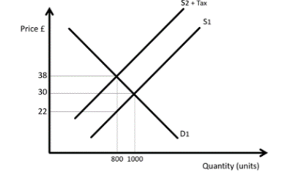

1. Consider the diagram above which shows imposition of an indirect tax on Good Y. Label the following on the diagram:
2. Price paid by consumer post indirect tax
3. Price received by the producer
4. Consumer Burden
5. Producer Burden
6. Government Revenue
7. Using diagrams, explain how burden of tax is split between producers and consumers if the good has:

* Elastic Demand
* Inelastic Demand